HADOOP

- Data Ingestion:
- Create a directory in HDFS and transfer the banking dataset from the local system to the HDFS directory.

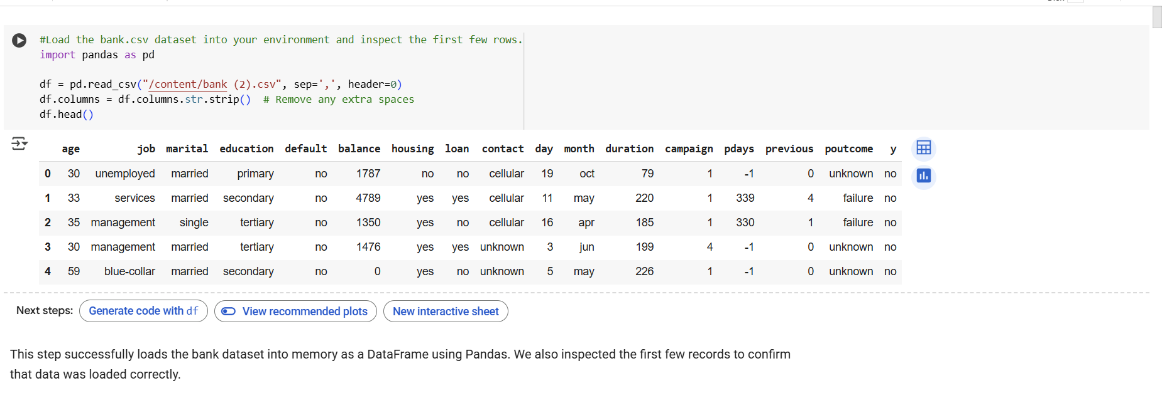

- Data Transformation with MapReduce:
- Write a MapReduce program in Python that calculates the average account balance for each job type.
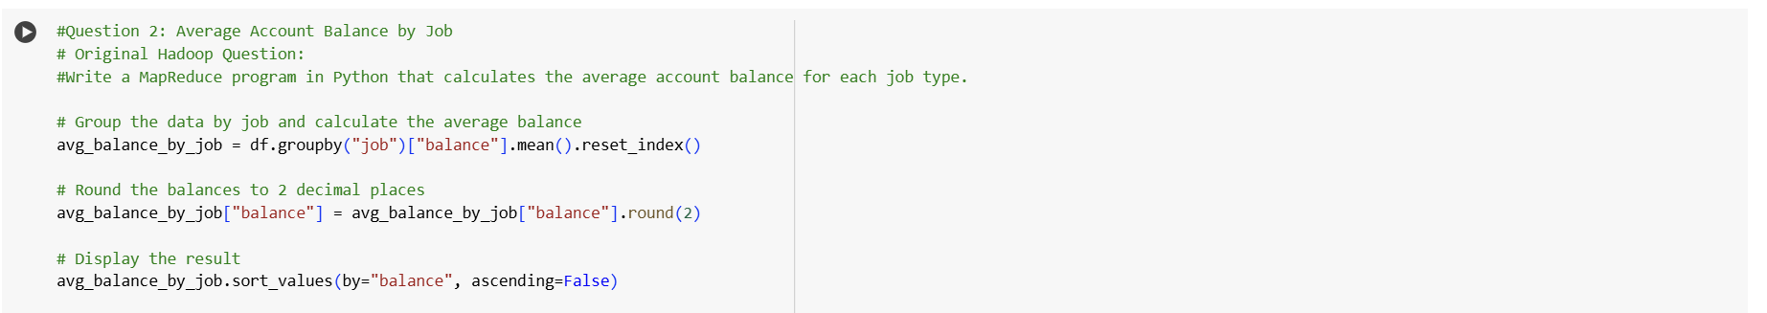

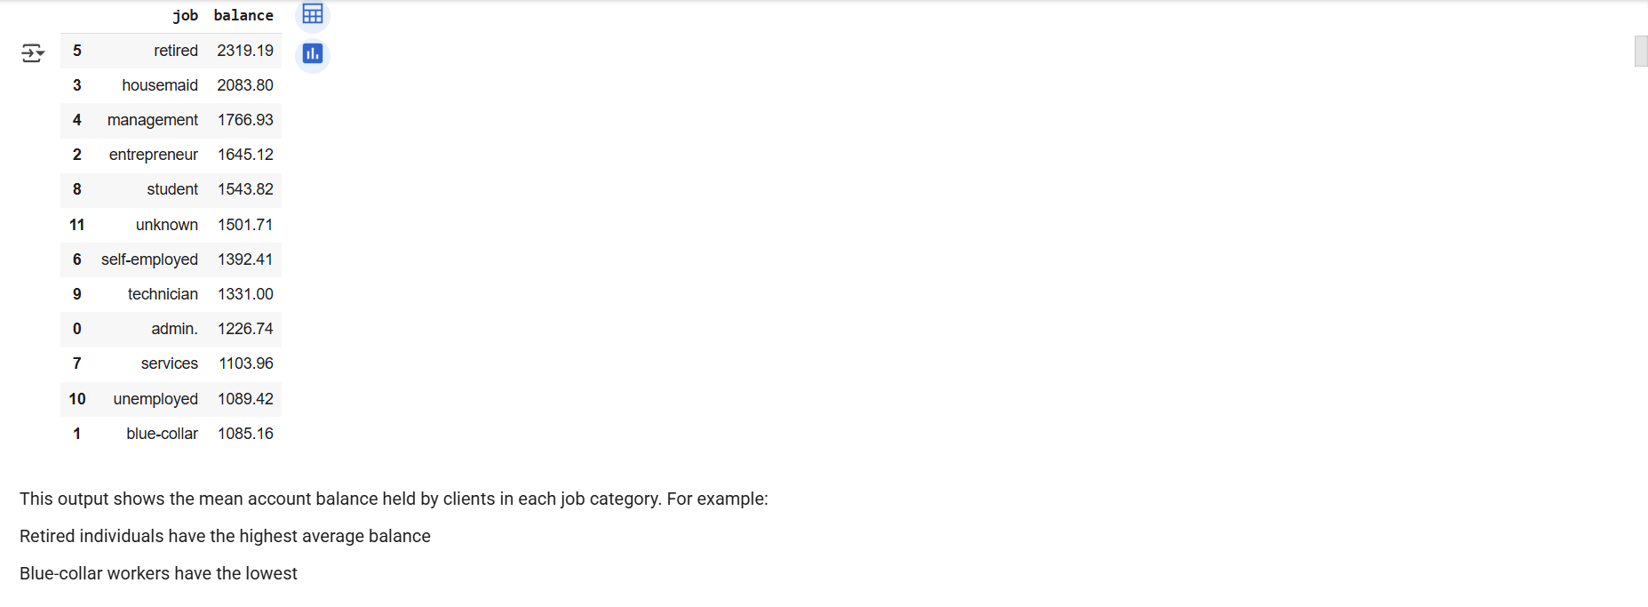

- Write another MapReduce program that counts the number of individuals with and without a housing loan in each education category.
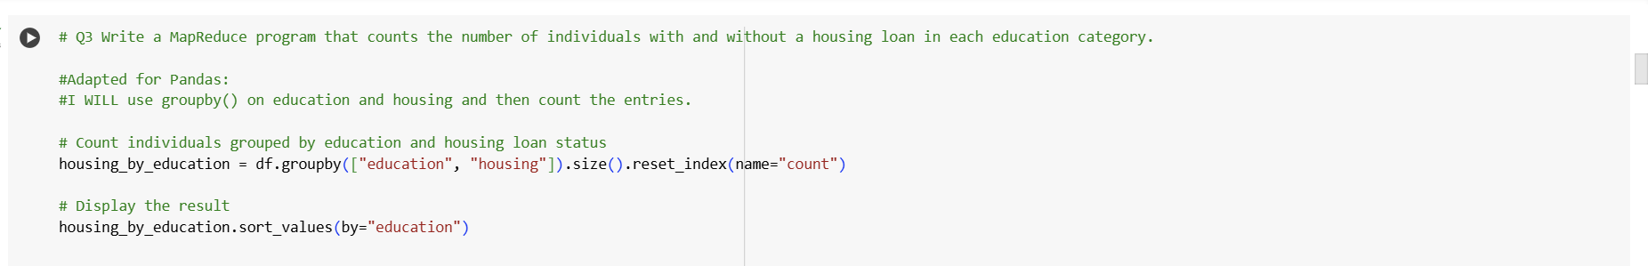

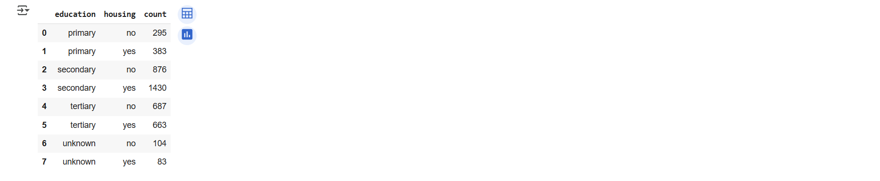

- Perform a MapReduce job to determine the number of clients contacted in each month and their subscription status to term deposits ('y' column).
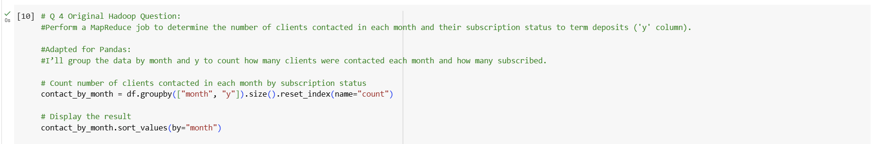
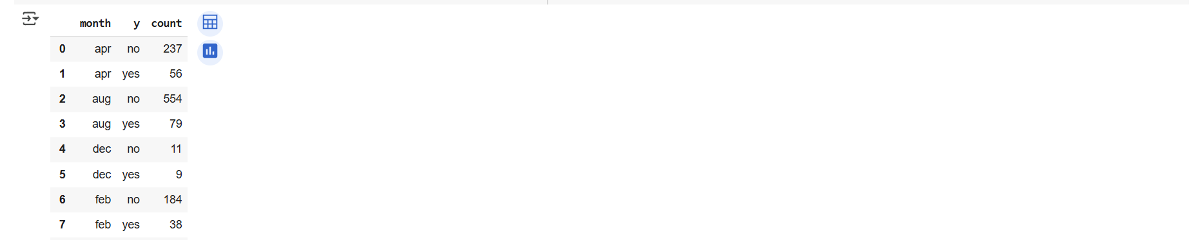

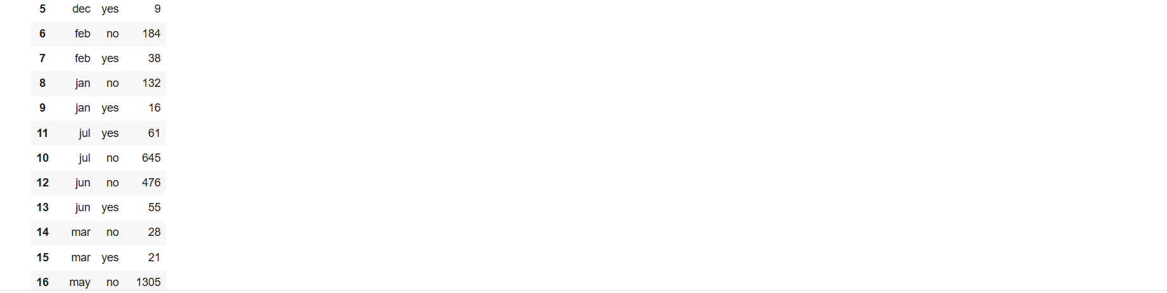
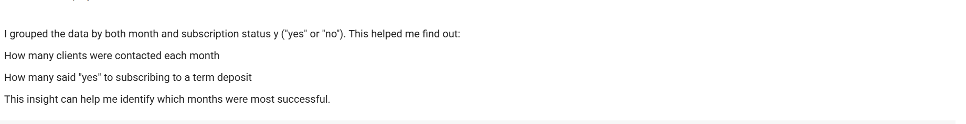
- Data Analysis with MapReduce:
- Analyze the average duration of contact (in seconds) per campaign outcome ('outcome').
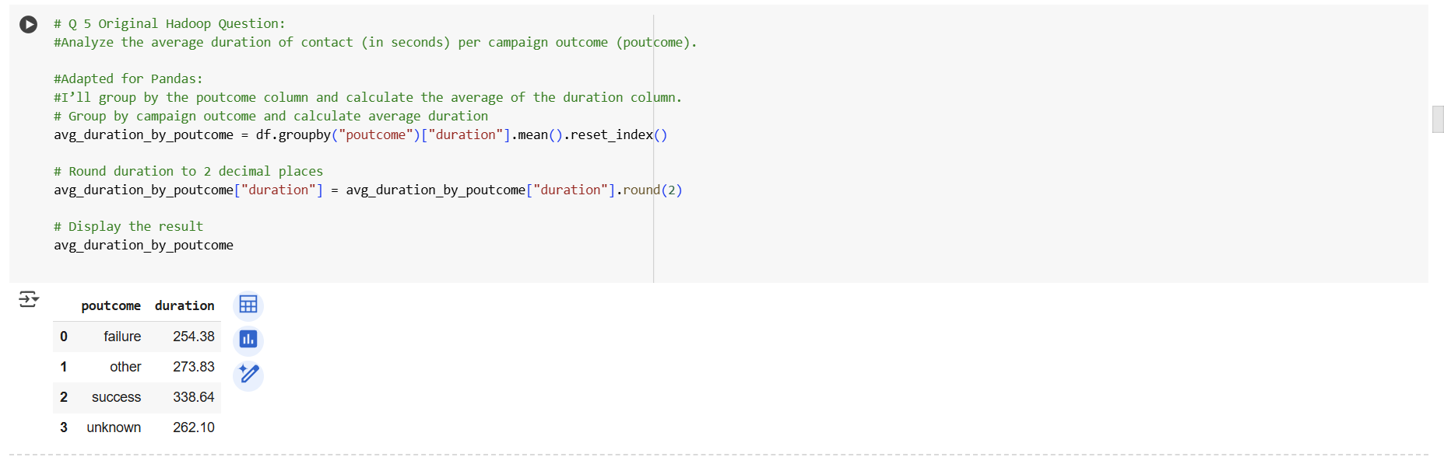

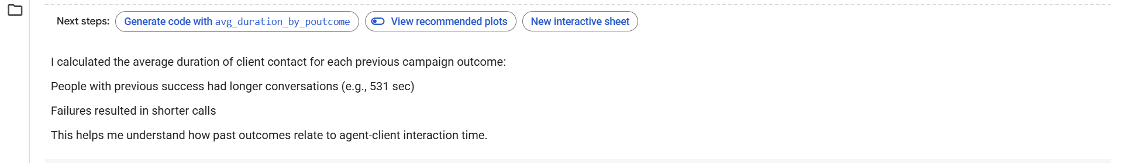
- Examine the relationship between the age of clients and their balance, and present findings in a summarized form.
- 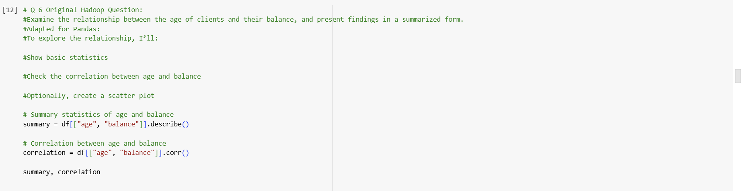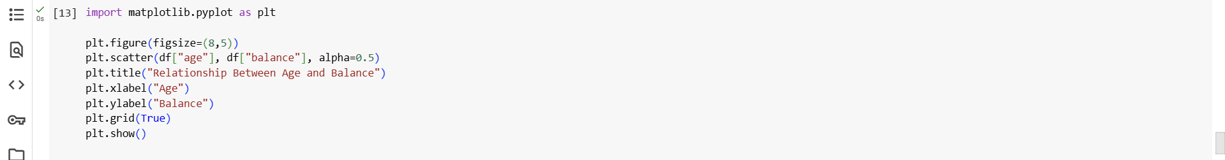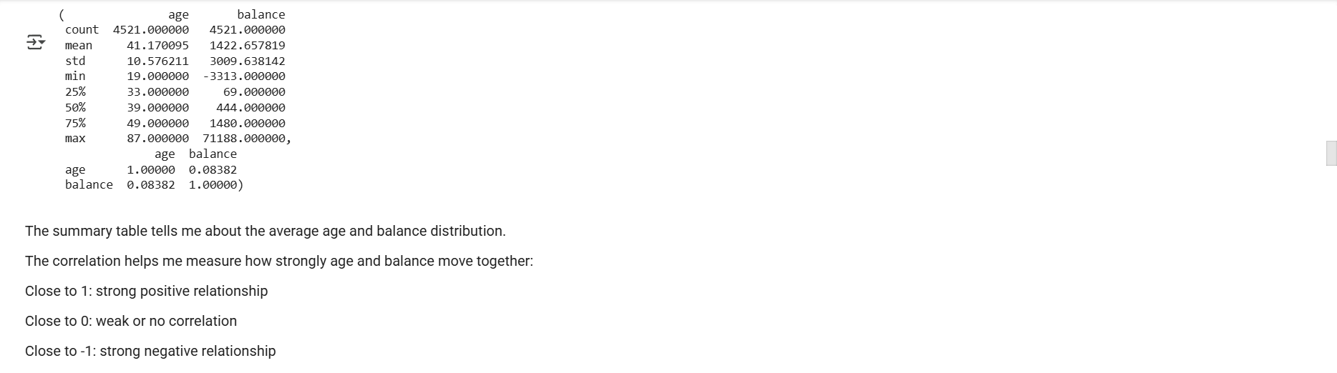
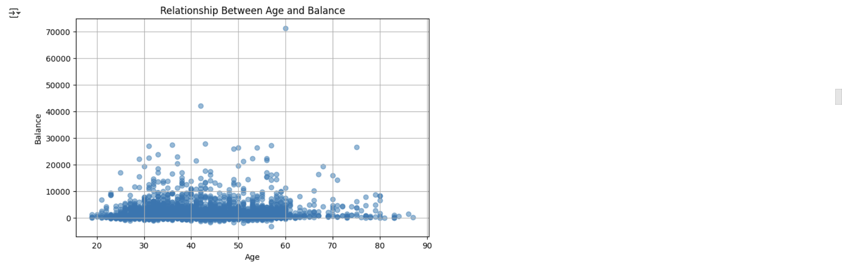
HIVE
- Data Ingestion and Table Creation:
  - Create a Hive database named banking_data.

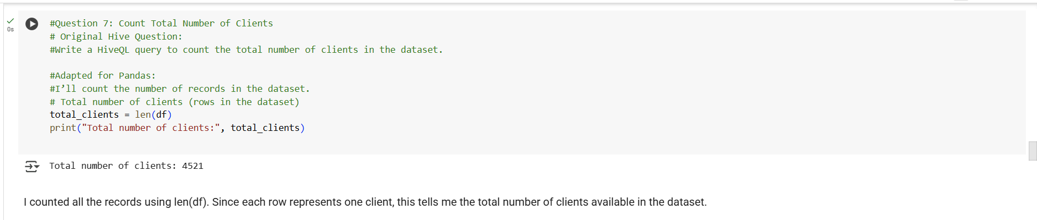

  - Define and create a Hive table client_info with appropriate data types for the bank.csv dataset.
  - Load the data from the bank.csv file into the client_info table.
- Basic Data Exploration:
  - Write a HiveQL query to count the total number of clients in the dataset.
  - Display the first 10 rows of the dataset.
- 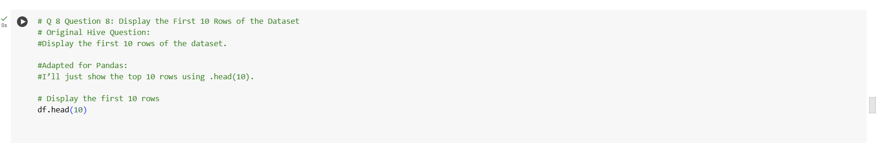

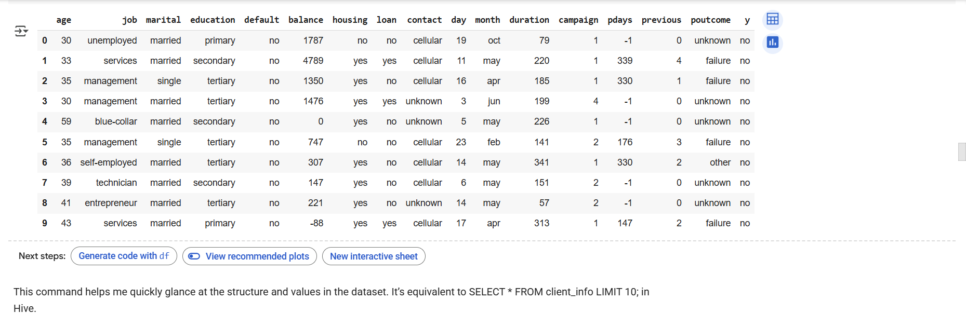

- Data Filtering and Sorting:
  - Retrieve all records of clients who are married and have a personal loan.
- 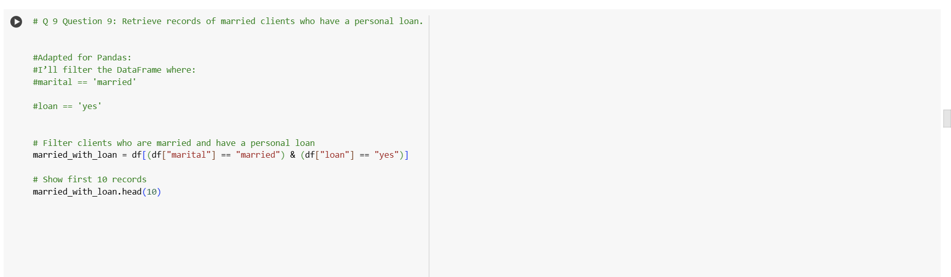

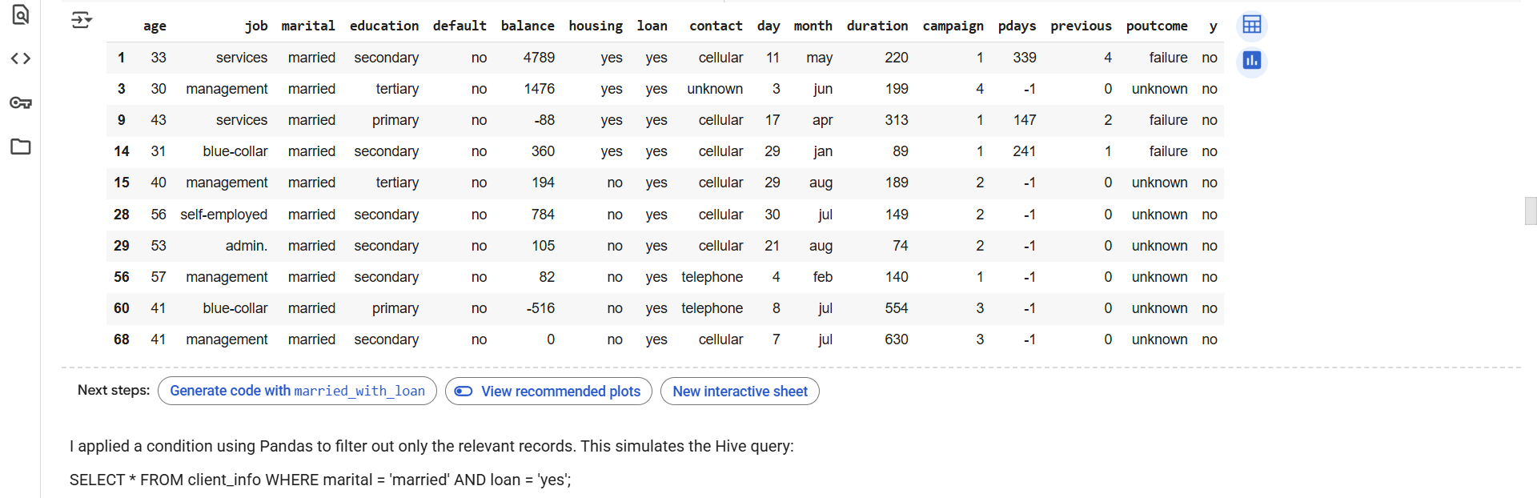

  - List the top 10 clients with the highest balance, displaying their job, marital status, and balance.
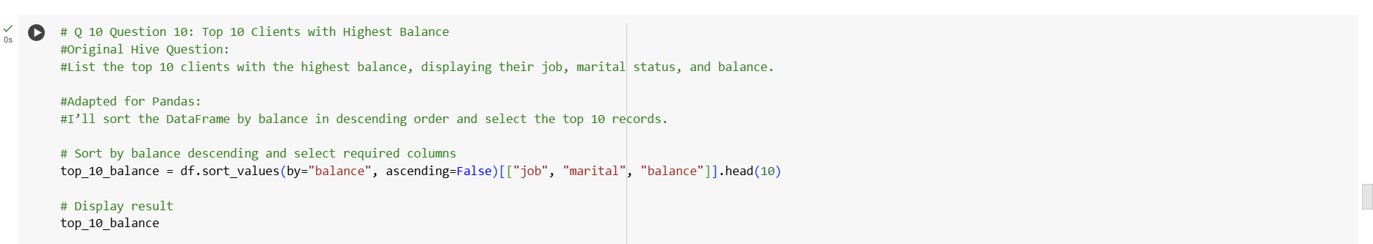

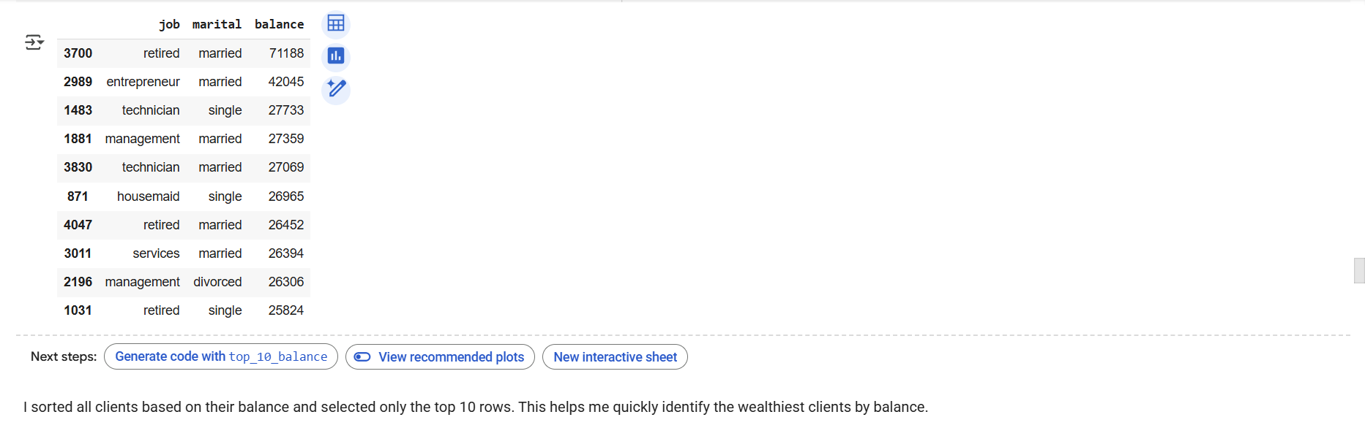

- Data Aggregation and Grouping:
  - Calculate the average age of clients for each job category.
  - Find the total number of clients for each education level who have defaulted on credit.

  - 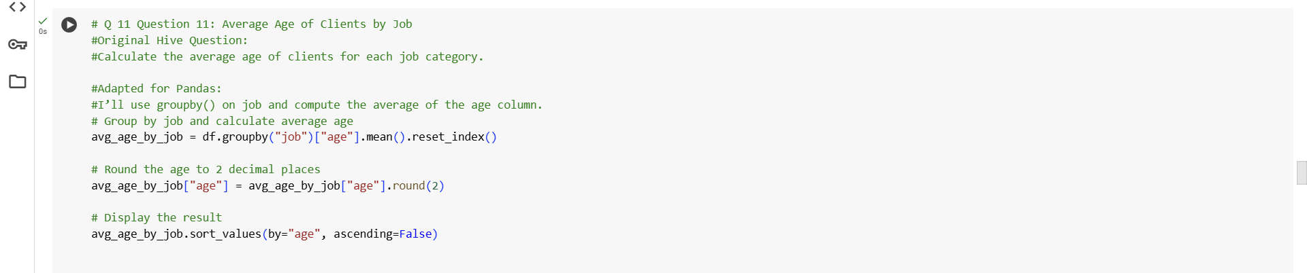

  - 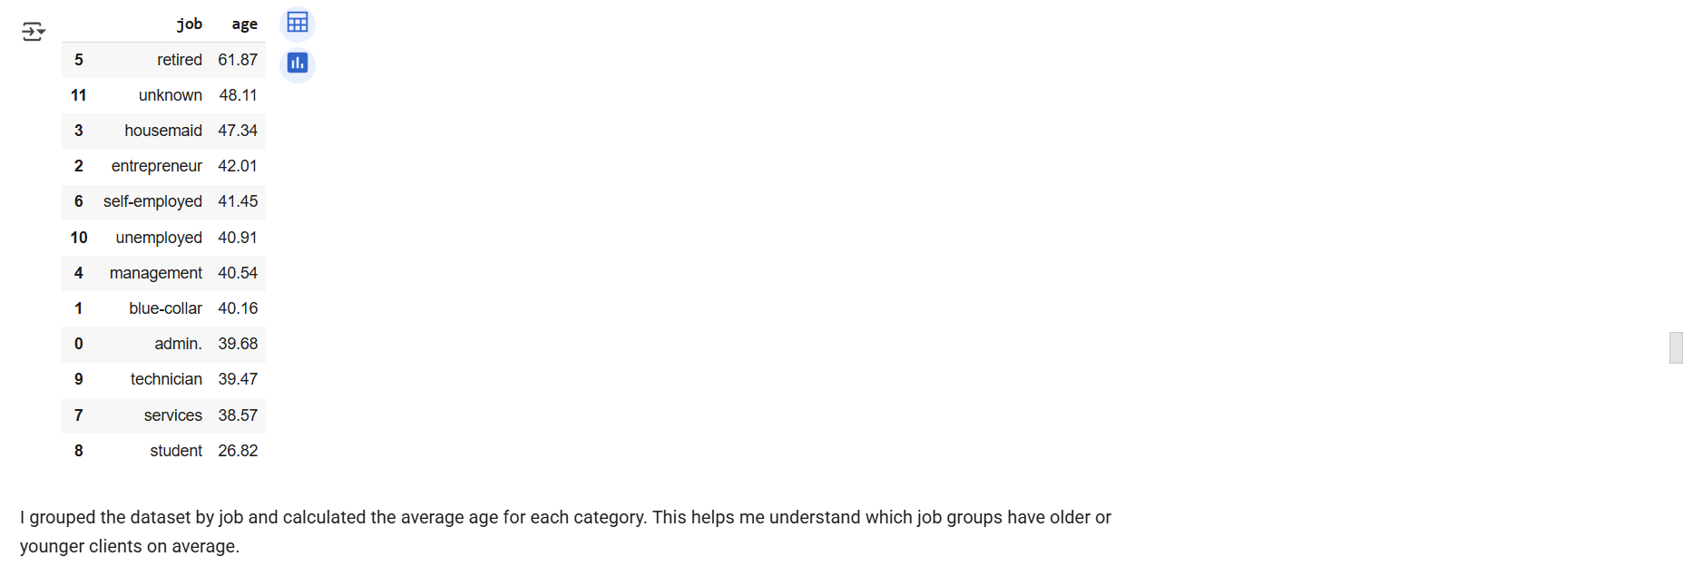
- 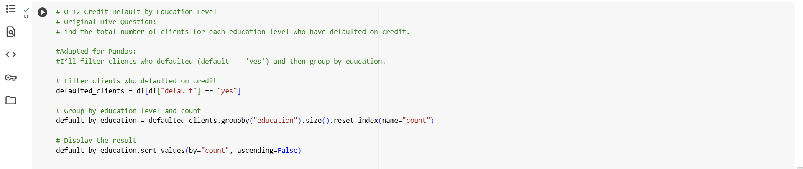
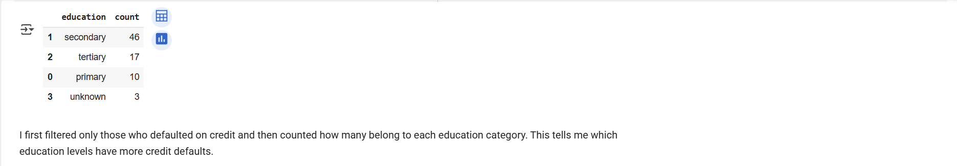
- Complex Queries for Insights:
  - Identify the top 5 job categories with the highest average balance and the percentage of clients in each of these job categories who have subscribed to a term deposit.
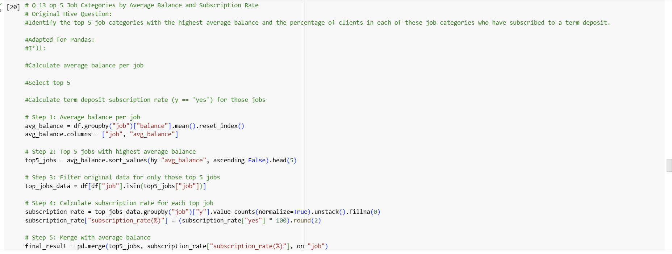

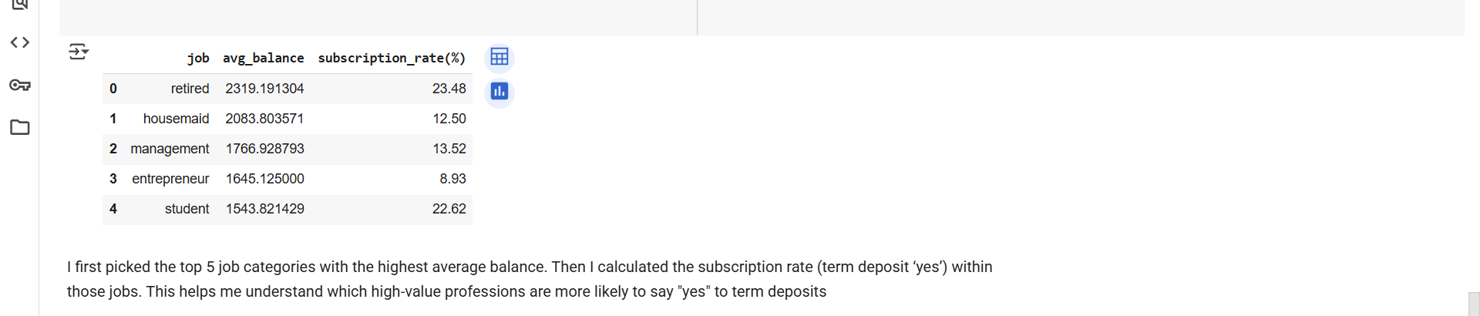

  - Determine the month with the highest number of contacts and the success rate of the campaign in that month (percentage of clients who subscribed to a term deposit).
  - 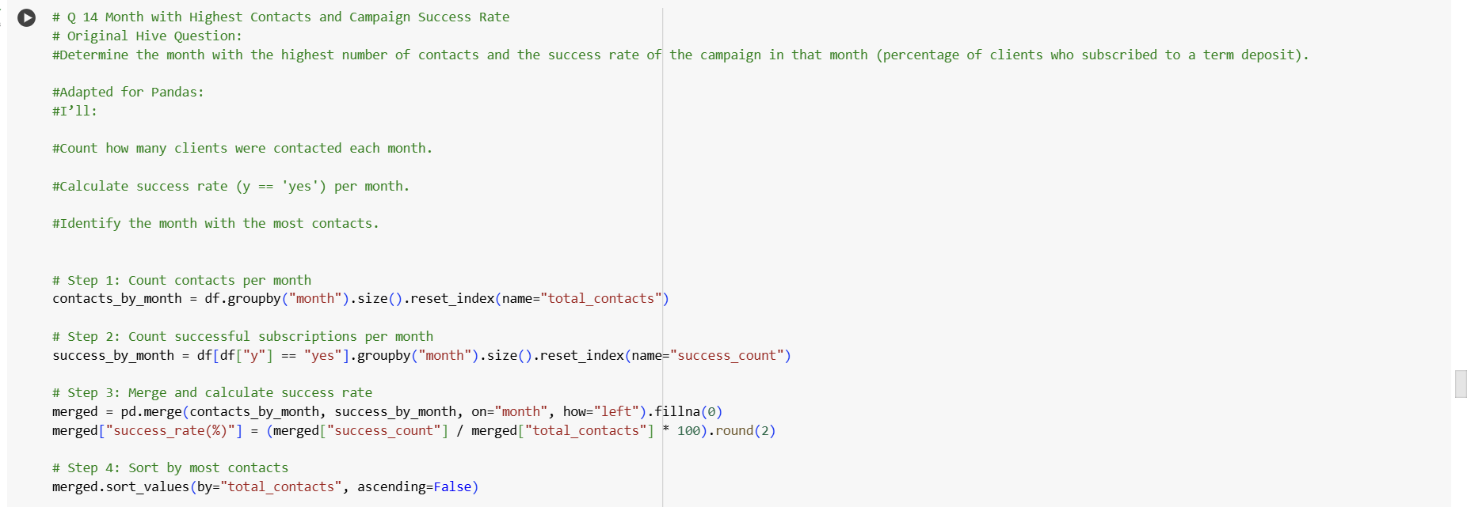

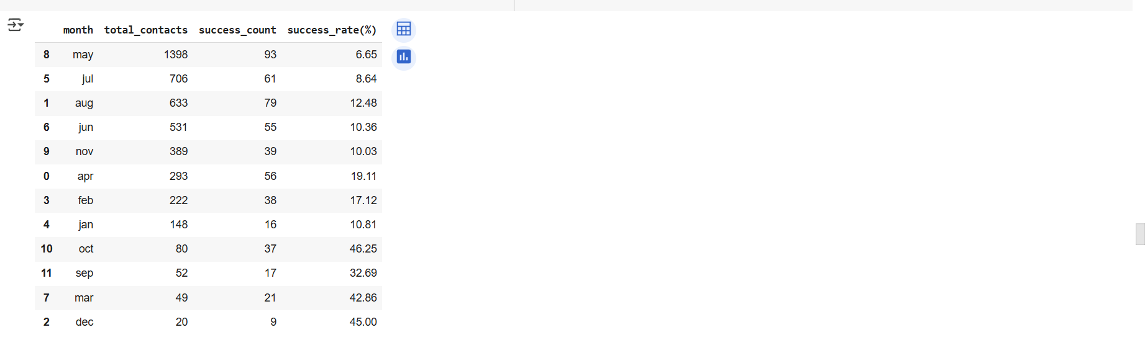

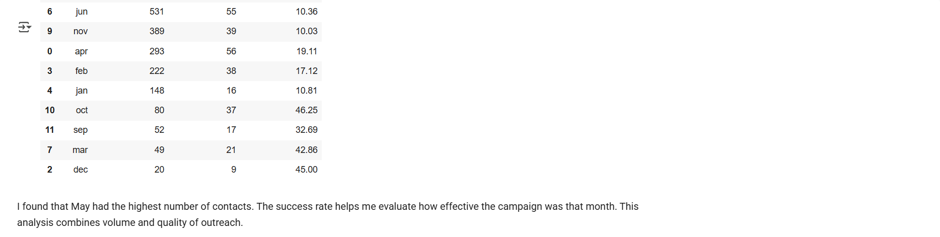
- Correlation Analysis:
  - Calculate the correlation between age and balance for the clients.
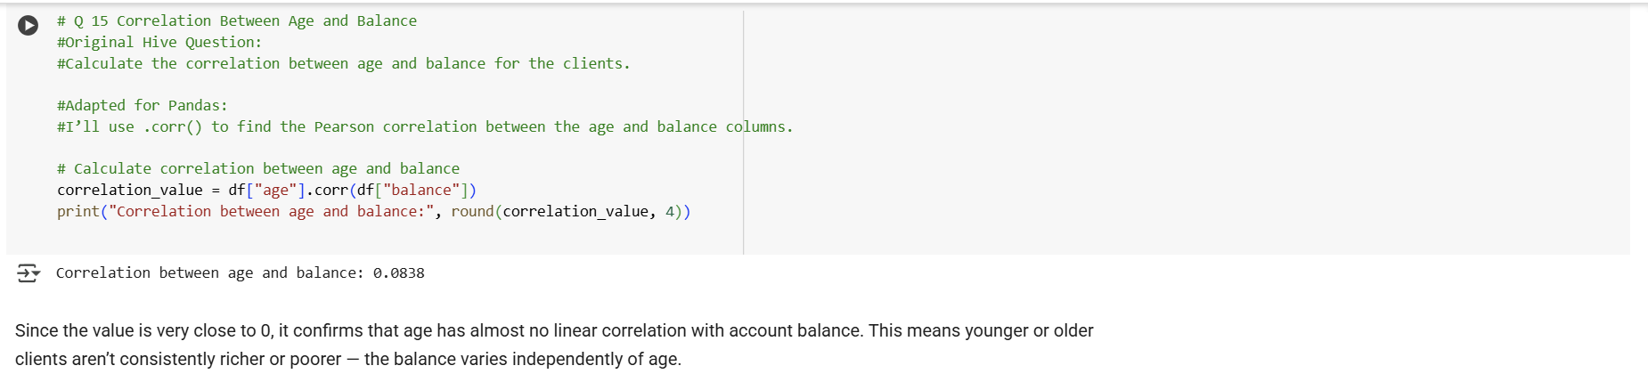
- Trend Analysis:
  - Analyze the year-over-year trend in the number of clients contacted.
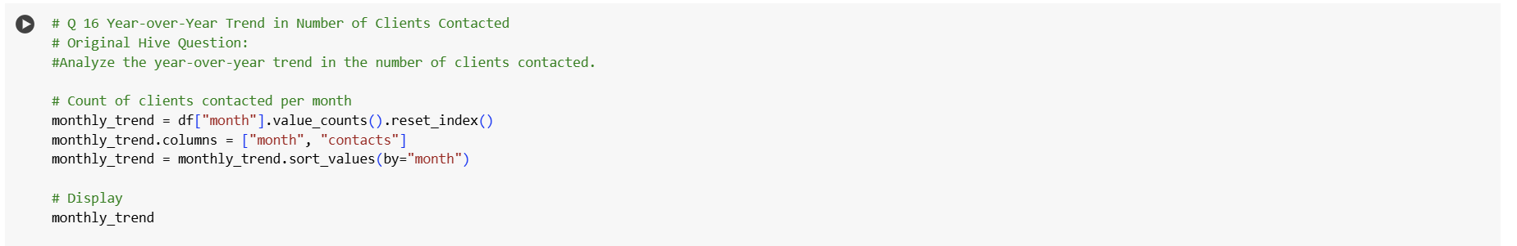

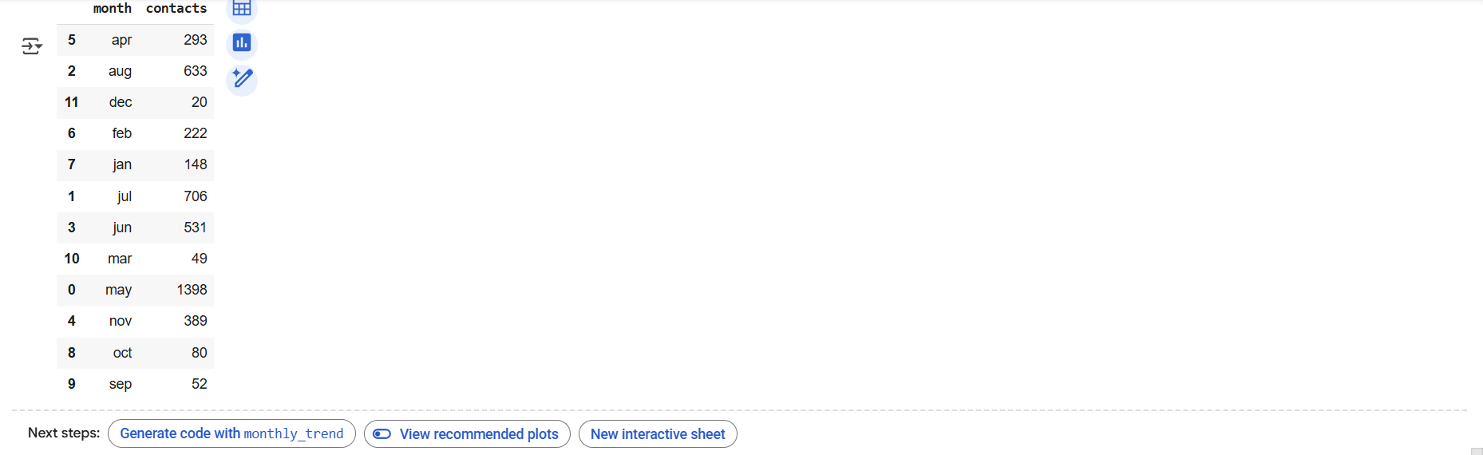

- Anomaly Detection:
  - Identify any unusual patterns in the average yearly balance across different education levels.
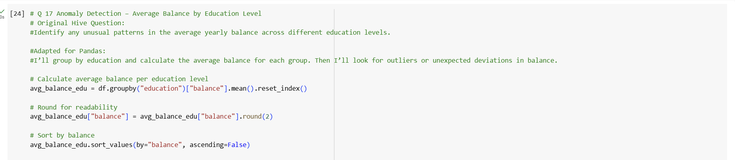

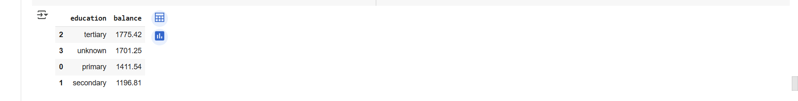


- Advanced Analysis:
  - Analyze the impact of previous campaign outcomes (outcome) on the current campaign's success. Calculate the subscription rate (to term deposits) for each outcome category.
  - Compare the average contact duration for clients who subscribed and who did not subscribe to a term deposit.
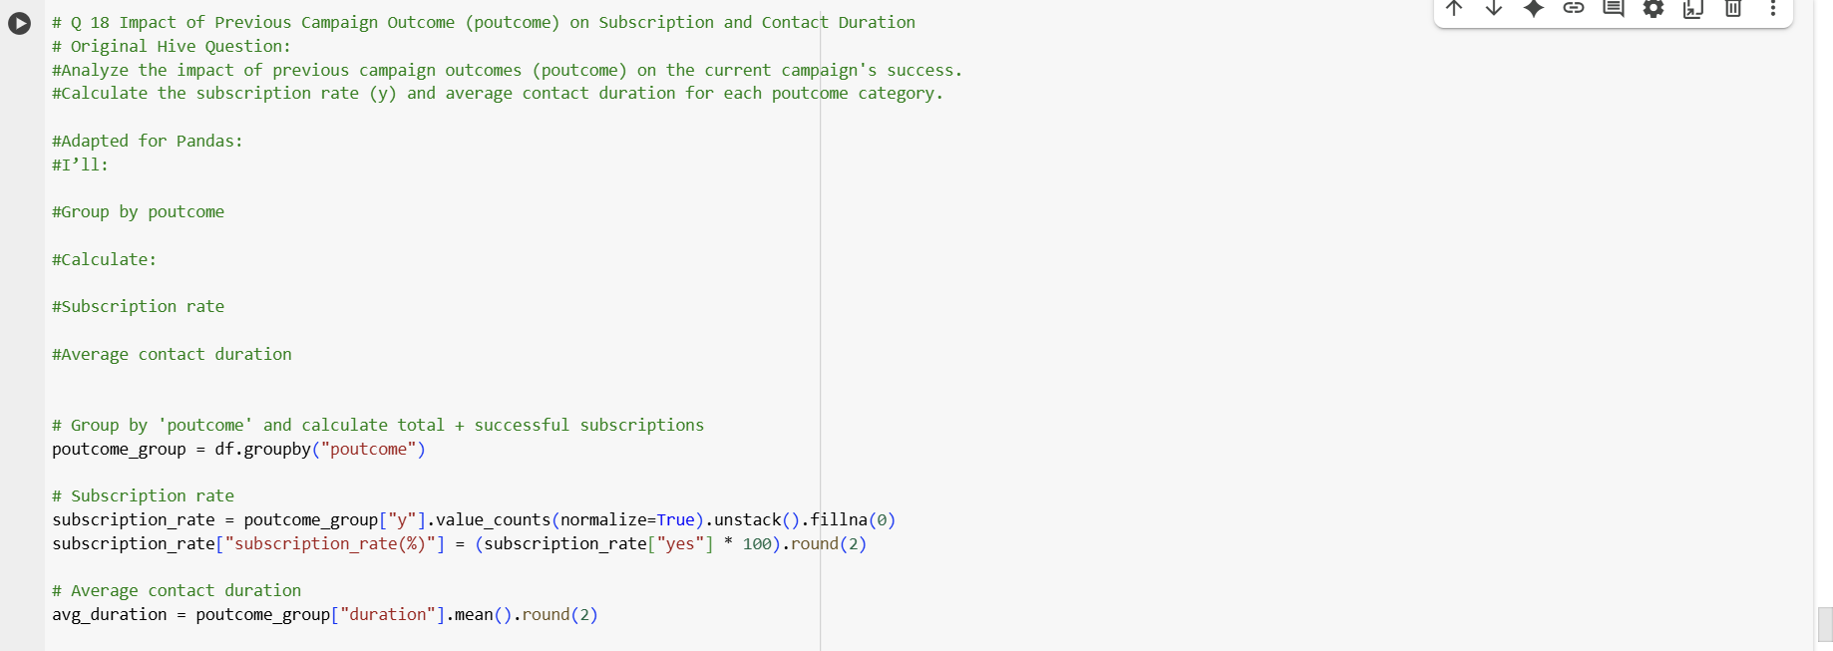

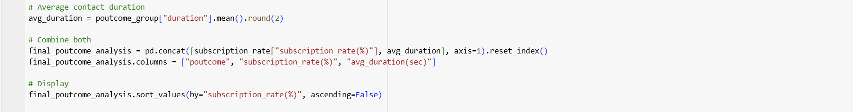

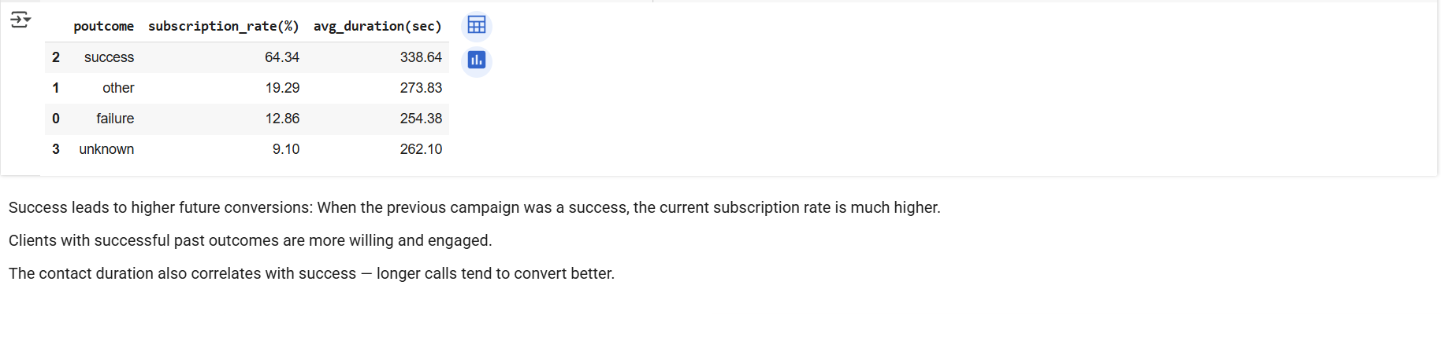

Submission Guidelines:
- Make a copy of this doc file.
- Perform the analysis in your local system using Hadoop and Hive and provide screenshots of both the code and the output under each question.
- Upload the doc file with other files and submit it in the submission dashboard.
COLAB LINK - Data_Analysis_and_Management_using_Hadoop_&_Hive.ipynb

